Title: Fano resonances meet Majorana fermions

Antonio Bianconi^{1*}.

¹Rome International Centre for Material Science Superstripes, RICMASS, via dei Sabelli 119A, 00185 Rome, Italy

Email: antonio.bianconi@ricmass.eu
Key words: spectromicroscopy, nano-x-ay diffraction, topological matter, Fano resonances

This work investigates the Fano resoances die to interplay of localized and delocalized states in complex topology of hyperbolic space.
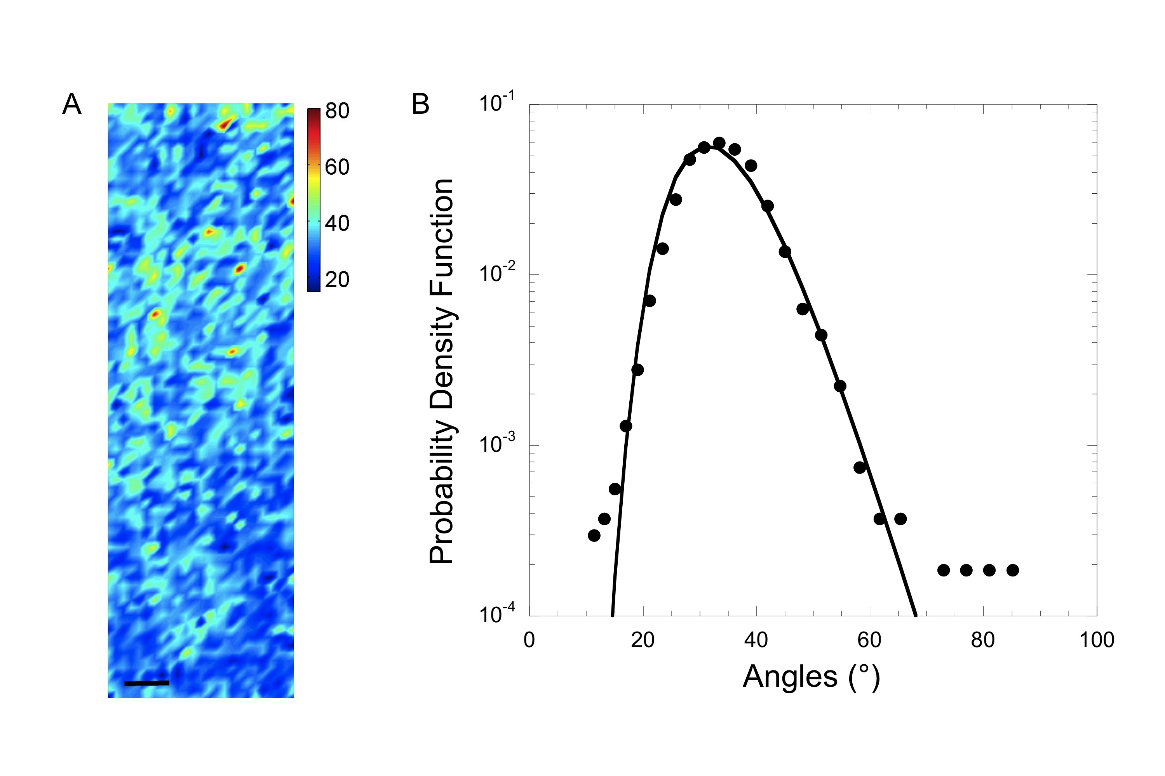
Figure 1: Map of power law fluctuations

References
1. A. Ricci et al. New Journal of Physics 16, 053030 (2014).

